SCIENCE CLASS TEST
Full marks-10
- Objective questions - (4 marks)
- Assertion (A): All invertebrates have skeleton.
Reason (R): Invertebrates are animals that lack a backbone.
    - Both A and R are true, and R is the correct explanation of A.
    - Both A and R are true, but R is not the correct explanation of A.
    - A is true, but R is false.
    - A is false, but R is true.

- Assertion (A): All reptiles have moist skin for breathing in water.
Reason (R): Amphibians, not reptiles, have moist skin for breathing.
    - Both A and R are true, and R is the correct explanation of A.
    - Both A and R are true, but R is not the correct explanation of A.
    - A is true, but R is false.
    - A is false, but R is true.

- Observe the given image.
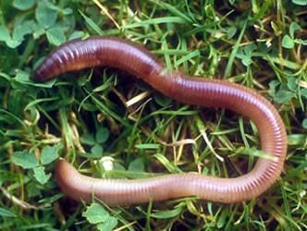
Choose the correct combination for the given animal.
- Amphibian, invertebrate, mammal
- Vertebrate, viviparous, reptile
- Invertebrate, terrestrial, oviparous
- Viviparous, semi-aquatic, aerial

- Statement 1 – All vertebrate animals are terrestrial animals.
Statement 2 – Amphibians can live both on land and in water.
    - Statement 1 is correct but statement 2 is incorrect.
    - Statement 2 is correct but statement 1 is incorrect.
    - Both the statements are correct.
    - Both the statements are incorrect.

- Subjective questions - (6 marks)
- Two animals were found in a desert: (2 marks)
- Animal X had scales on its body.
- Animal Y had thick layer of fur on its body.
Identify the classes of Animal X and Y on the basis of their reproduction.

- An animal was seen swimming in the ocean. (2 marks)
- Classify this animal based on its habitat.
- What help them to survive them easily in this habitat?

- During a school trip, students read a board near two camels: "One of us survives sandstorms, the other survives snowstorms!" Explain how both camels are adapted to their habitats. (2 marks)

